Session-2 - Lab 2 – Creating Hive Table

# Create Hive table on Tweets

* + 1. In this step we will create external hive table which we will leverage to extract the data and gather data quality and usefulness.
    2. First verify that we our data collection stream is capturing data from “twitter firehose”

|  |
| --- |
| hadoop fs -du /tmp|grep tweets_staging |

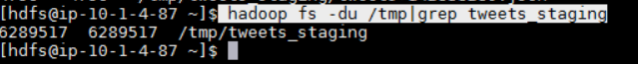

* + 1. If NiFi stream is operational, you should see change in size of dataset.
    2. To create hive table, first we need to login to hive or beeline(Hive cli replacement)
       1. Login to hive by typing “hive”

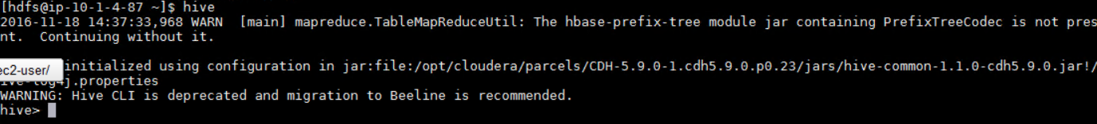

* + - 1. By default there is database named “default”, we will use default for this lab. Let’s create new table called “tweets_text.”

|  |
| --- |
| CREATE EXTERNAL TABLE tweets_text(  tweet_id bigint,  created_unixtime bigint,  created_time string,  lang string,  displayname string,  time_zone string,  msg string)  ROW FORMAT SERDE  'org.apache.hadoop.hive.serde2.lazy.LazySimpleSerDe'  WITH SERDEPROPERTIES (  'field.delim'='|',  'serialization.format'='|')  STORED AS INPUTFORMAT  'org.apache.hadoop.mapred.TextInputFormat'  OUTPUTFORMAT  'org.apache.hadoop.hive.ql.io.HiveIgnoreKeyTextOutputFormat'  LOCATION  '/tmp/tweets_staging'  ; |

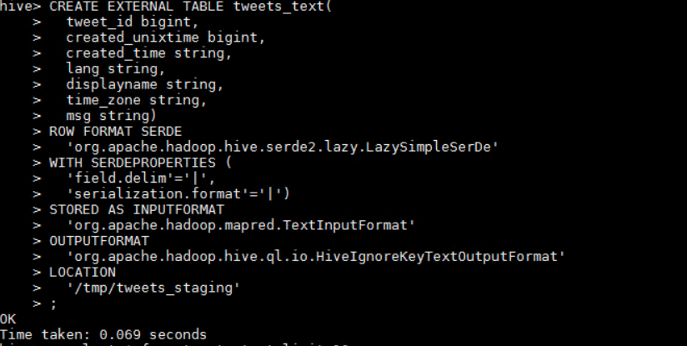

|  |
| --- |
| desc tweets_text; |

* + - 1. Verify the table creation was successful:

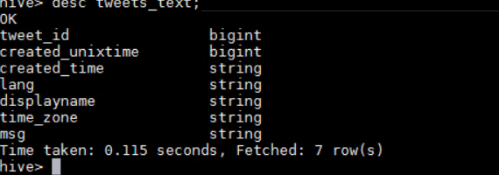

* + - 1. Notice that data is already in text and readable format, NiFi processed and cleaned the data prior to writing to HDFS. Also, data can be written in its raw format, but tools like NiFi workflow makes it simple for users to scrub the data.

# Query data via CLI and Hue

* + 1. Now that we have data ingested into HDFS, let’s execute some basic queries to find out data structure.
       1. Query table to find total row counts

|  |
| --- |
| **Select count(*) from tweets_text;** |

* + - 1. Query table to find total tweets count by “displayname”

|  |
| --- |
| **select count(*) , displayname from tweets_text group by displayname;** |